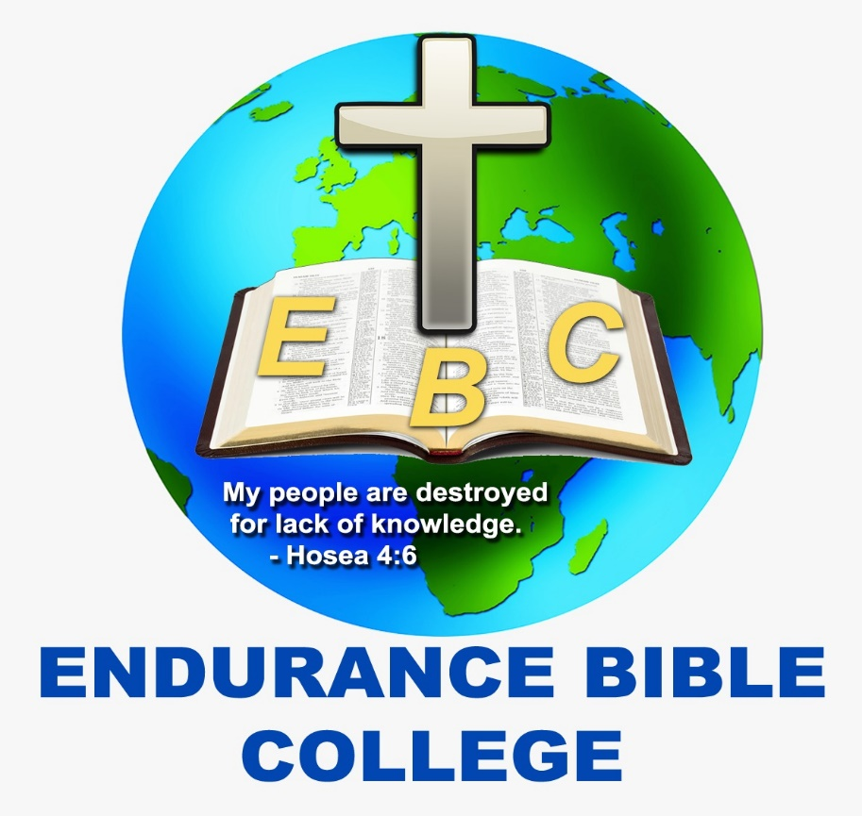

DIPLOMA IN BIBLE AND THEOLOGY COURSES

2023

YEAR 1

TERM ONE
COURSE CODE | TITLE | HRS
DBS111 | OLD TESTAMENT SURVEY 1 | 3
DED111 | INTRODUCTION TO RESEARCH AND WRITING | 3
DGE111 | CHRISTIAN COUNSELLING | 3
DTH111 | BIBLE DOCTRINE | 3
DTH112 | HERESIES | 3
 | TERM’S TOTAL | 15

TERM TWO
COURSE CODE | TITLE | HRS
DBS122 | OLD TESTAMENT SURVEY II | 3
DTH123 | PNEUMATOLOGY | 3
DED122 | CHRISTIAN LEADERSHIP | 3
DED124 | INTRODUCTION TO PHILOSOPHY | 3
DTH124 | ECCLESIOLOGY | 3
 | TERM’S TOTAL | 15

TERM THREE
COURSE CODE | TITLE | HRS
DBS133 | OLD TESTAMENT SURVEY III | 3
DTH135 | HERMENEUTIC | 3
DTH136 | SYSTEMATIC THEOLOGY | 3
DGE132 | FIELD MINISTRY | 3
DTH137 | MAN AND SIN | 3
 | TERM’S TOTAL | 15

YEAR TWO COURSES
TERM ONE
COURSE CODE | TITLE | HRS
DBS214 | NEW TESTAMENT SURVEY I | 3
DTH218 | SOTERIOLOGY | 3
DTH219 | HOMILETICS | 3
DED213 | CHRISTIAN EDUCATION | 3
DGE213 | DEMONOLOGY | 3
 | TERM’S TOTAL | 15HRS

TERM TWO
COURSE CODE | TITLE | HRS
DBS225 | NEW TESTAMENT SURVEY II | 3
DGE224 | SPIRITUAL DEVELOPMENT | 3
DTH220 | CHRISTIOLOGY | 3
DED225 | CHURCH HISTORY | 3
DGE225 | EVANGELISM | 3
 | TERM’S TOTAL | 15HRS

TERM THREE
COURSE CODE | TITLE | HRS
DBS236 | NEW TESTAMENT SURVEY III | 3
DGE236 | BIBLE AND MORAL ETHICS | 3
DGE213 | ESCHATOLOGY | 3
DGE237 | CULTS | 3
 | TERM’S TOTAL | 12

